### Programming to RAM

Program Talaria TWO’s ELF to RAM by clicking on PROG RAM.

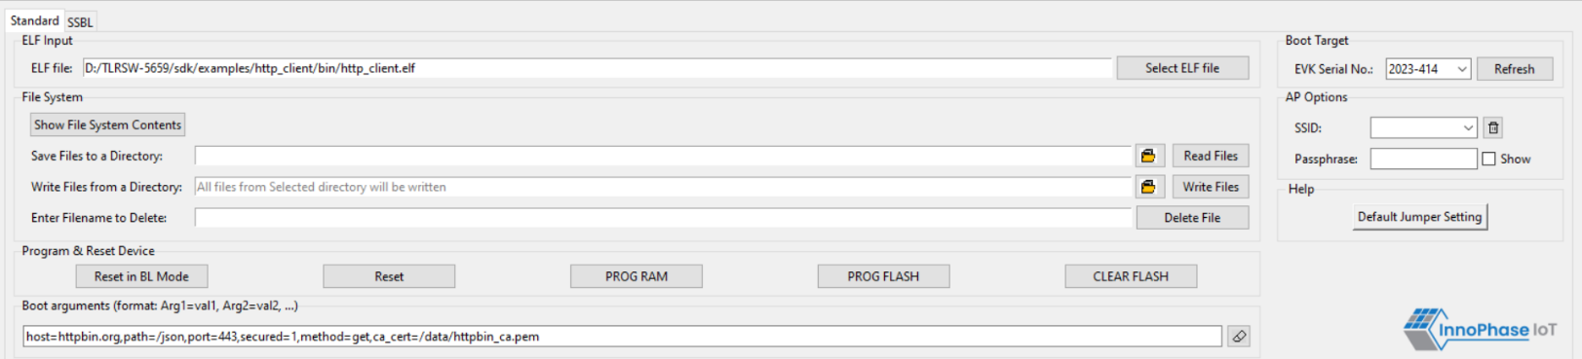

Figure 26: Programming to RAM

 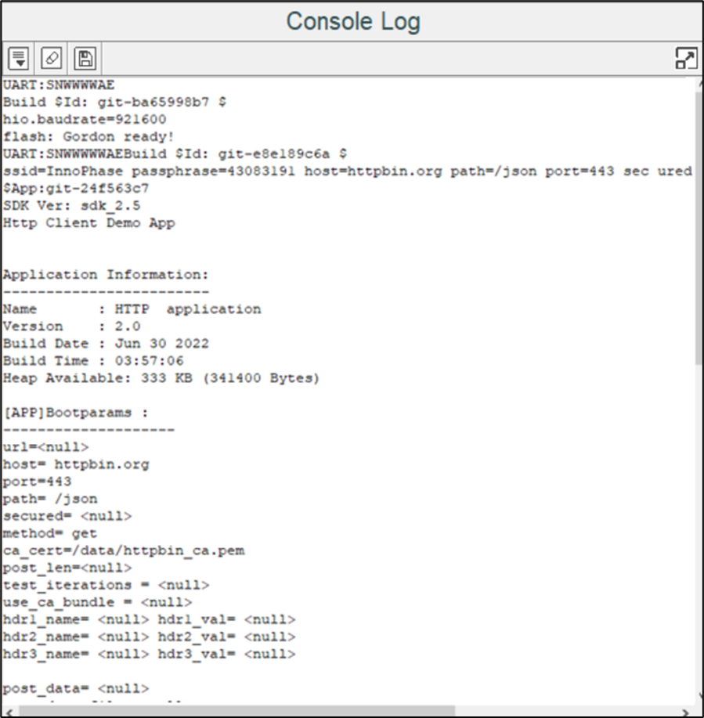

Figure 27: Console Output – PROG RAM

PROG RAM will clear the application from Flash. The user is alerted of the same during PROG RAM through a pop-up message as shown in Figure 28. User can select the Do not show again checkbox to stop the pop-up message from appearing the next time.

 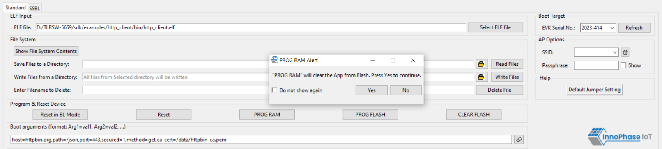

Figure 28: PROG RAM alert message